**Technical Interview Prep: Fundamentals of AI and ML**

**1. AI, Machine Learning, and Deep Learning Differentiation**

AI is short for artificial intelligence and is a term that was coined by computer scientist John McCarthy in 1955. The concept of intelligent machines dates back to ancient times however it was Alan Turning’s famous Turing Test paper which proposed the initial benchmark for artificial intelligence. AI has come leaps and bounds from it’s earliest models which were essentially complex if-then statements to now relying on complex machine learning algorithms powered by Graphical Processing Units with immense computational power.

Artificial intelligence is a term used to describe computers that can perform tasks typically requiring human intelligence (e.gs.: reasoning, learning, decision making). Popular chatbots today like Google’s Gemini and ChatGPT use machine learning algorithms (or “ML” for short) to respond to data input by users (typically questions). Machine learning enables computers to learn from data without being explicitly programmed for every task.

Machine learning considered to be a form of artificial intelligence in that it performs tasks which would normally require human intelligence (e.gs.: playing chess, driving a vehicle). It is worth mentioning the Artificial General Intelligence (AGI) theory which conceives artificial intelligence reaching a level wherein it’s capabilities are on par or greater than that of human intelligence (as opposed to only being able to perform limited functions which are akin to human intelligence, such as the machine learning method).

Deep learning is a type of machine learning that uses neural networks to analyze data, learn complex patterns, similar to how human brain functions. Neural networks are a type of machine learning algorithm inspired by the human brain that process data using interconnected nodes called neurons which are organized in layers. A neuron is a simple mathematical function that receives input from other neurons, perform a calculations, and passes the result to the next layer of neurons.

Neural networks are trained on sets of data using machine learning techniques like representation learning wherein a system attempts to automate the process by which useful insights are acquired from raw data. Representation learning transforms raw data into an easier to understand format without the need for human engineering. AI automation uses the methods described above to process data in ways which are more dynamic than the basic if-then rules typically associated with automation.

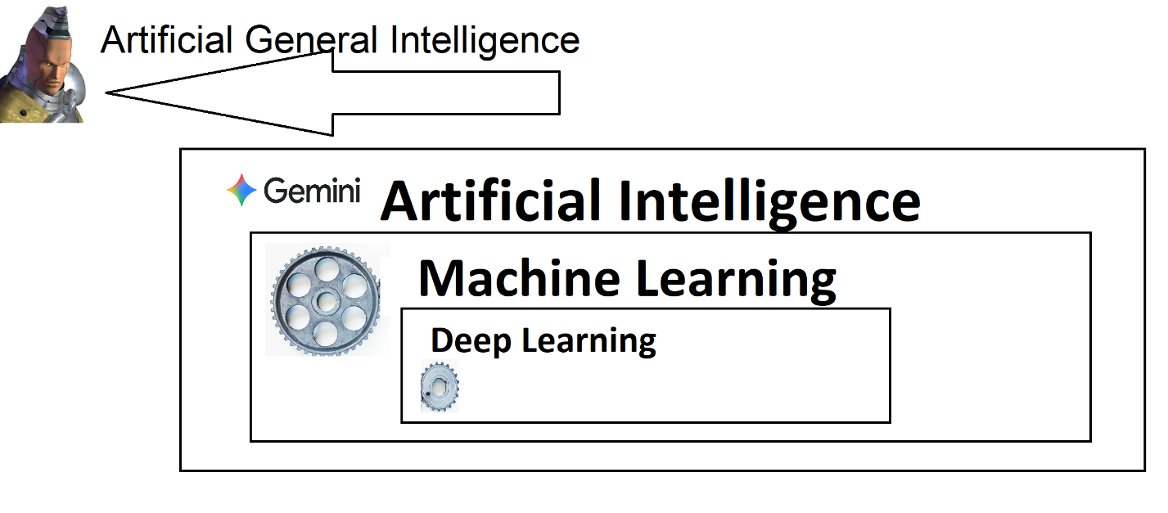

**2. Supervised Learning Explanation**

* **Concept:** Define supervised learning by focusing on the **nature of the training data**.

Supervised learning is a process by which AI models are trained under the supervision of humans. Human supervision can instruct/teach AI models how to classify and handle data input() by providing what are called ground truths for AI models. Ground truths are a sort of north-star reference point for data classification (e.g.: an AI being trained on cats and dogs might use a picture of a tabby cats as ground truths).

Without supervised learning an AI model might “think” it’s generating profound insights via data output () when in reality it’s generating useless insights. Humans can help by providing labeled data for the AI model. Mapping function involves a collaboration between humans and machines.

Predictions are outputs generated by AI models which makes “educated” guesses about outcomes based on learned patterns. Regressions are a form of predictions which always involve a quantity. Classifications involve sorting data into predefined categories. Unsupervised learning is that which is done without the supervision of a human.

**3. Classification Problem & STAR Method Case Presentation**

I was tasked with enhancing a business website for a small business. The website needed an integrated booking system which allowed users to schedule appointments by 15-minute windows and leave messages. Ideally the booking system would not allow users to double-book an appointment slot. The budget allocated was very low.

Addressing potential security and performance concerns with the booking system; I needed to make sure that the booking form did not fall victim to bots or fake appointments. The booking system needed to be able to differentiate between messages there were spam and message which were not spam. The booking system needed to be able to perform classification based on data inputs. Due to the low budget, this was accomplished using a third party solution which used CAPTCHA and a variety of other methods like message filtering for profanity, to determine if a message should be labeled “spam” or “not spam”. The result was a UX-friendly website with a booking system which worked well for everyone and which did not fall victim to spam messages or appointment bookings.

https://www.lsu.edu/ai/what-is-ai.php

https://aws.amazon.com/what-is/deep-learning/#:~:text=Computers%20use%20deep%20learning%20algorithms,Recommendation%20engines

<https://www.computerscience.org/resources/learn-ai/>

**Assignment Goal**

The goal of this assignment is to simulate a technical interview setting, requiring you to clearly articulate fundamental concepts in Artificial Intelligence (AI), Machine Learning (ML), and Deep Learning (DL). You must demonstrate both your conceptual knowledge and your ability to communicate effectively under pressure, specifically by using the **STAR method**  ([https://capd.mit.edu/resources/the-star-method-for-behavioral-interviews/Links to an external site.](https://capd.mit.edu/resources/the-star-method-for-behavioral-interviews/)) for presenting a case example.

**Prompt**

Prepare a response for the following three-part technical interview question:

1. **Explain the difference between AI, Machine Learning, and Deep Learning.**
2. **What is supervised learning?**
3. **Give an example of a classification problem, and present it using the STAR method.**

**Technical & Submission Requirements**

* **Format:** A single video recording (maximum 7 minutes).
* **Visibility:** The video must be uploaded to YouTube as **Public** or **Unlisted**.
* **Content:**
  + **Screen & Face:** Your video must clearly show **both your face (webcam) and your screen** (e.g., using a tool like OBS, Zoom, or Loom). You should be visible throughout the entire explanation.
  + **Visual Aids:** Use your screen to present **one or two key visual aids** to support your explanation (e.g., a Venn diagram for the AI/ML/DL differences, a simple chart for the classification example). *Do not just read slides.*
  + **Process Talk-Through:** Verbally explain your reasoning and concepts clearly, ensuring an interviewer can follow your logic.
* **Submission:** Submit the **public or unlisted YouTube link** to the designated assignment drop box.

**Detailed Content Guidelines**

**1. AI, Machine Learning, and Deep Learning Differentiation**

* **Concept:** Clearly define and differentiate the three terms, focusing on their **relationship** (e.g., as nested subsets) and their **historical context or approach**.
* **Keywords to use:** **Automation**, **Algorithms**, **Data**, **Neural Networks**, **Representation Learning**, **General AI** (briefly).
* **Visual Aid Suggestion:** Use a **Venn Diagram** or a simple **hierarchy chart** to illustrate the relationship.

**2. Supervised Learning Explanation**

* **Concept:** Define supervised learning by focusing on the **nature of the training data**.
* **Keywords to use:** **Labeled Data**, **Input** () and **Output** (), **Mapping Function**, **Ground Truth**, **Prediction**, **Regression** (to differentiate briefly), **Classification**.
* **Analogy Suggestion:** Use a clear, simple analogy, such as "teaching a child with flashcards."

**3. Classification Problem & STAR Method Case Presentation**

Choose a specific classification problem (e.g., predicting customer churn, email spam detection, image classification). Present your experience or approach to this problem using the **STAR Method**:

* **S - Situation:** Briefly set the context. *What was the problem we were trying to solve?* (e.g., "In a previous project, we needed to automatically filter harmful content on a social media platform.")
* **T - Task:** Detail your specific goal. *What were you or your team responsible for?* (e.g., "My task was to build a binary classification model to determine if a post was 'Harmful' or 'Safe'.")
* **A - Action:** Describe the steps you took. *What specific techniques, models, or data preparation methods did you use?* (e.g., "I started with data cleaning and feature engineering of the text, then evaluated Logistic Regression and a simple Neural Network, ultimately choosing the latter due to better  score.")
* **R - Result:** Quantify the outcome. *What was the result of your action?* (e.g., "The final model achieved 92% accuracy and reduced the false negative rate by 15%, significantly improving platform safety.")

**Grading Rubric (100 Points)**

| Category | Criteria | Points |
| --- | --- | --- |
| **I. Content Accuracy & Depth** (40 pts) |  |  |
| AI, ML, DL Differentiation | Clear, accurate, and concise explanation of the relationship and differences. | 15 |
| Supervised Learning | Accurate definition emphasizing labeled data and mapping function. | 10 |
| Classification Example | Problem is clearly defined and is a true classification task. | 5 |
| STAR Method Application | Clear and structured application of S-T-A-R to the classification example. | 10 |
| **II. Presentation & Communication** (35 pts) |  |  |
| Clarity & Coherence | Explanation is easy to follow and technically sound. **Process is talked through.** | 15 |
| Visual Aids | Effective use of screen-sharing to support concepts (e.g., Venn diagram, charts). | 10 |
| Professionalism & Tone | Poised, confident, and uses appropriate technical language (simulating interview). | 10 |
| **III. Technical Requirements** (25 pts) |  |  |
| Video Requirement | Face and screen are clearly visible throughout the entire video. | 10 |
| Time Constraint | Video is 7 minutes or less. | 5 |
| Submission | Correct YouTube link (public or unlisted) is submitted. | 10 |
| **Total** |  | **100** |